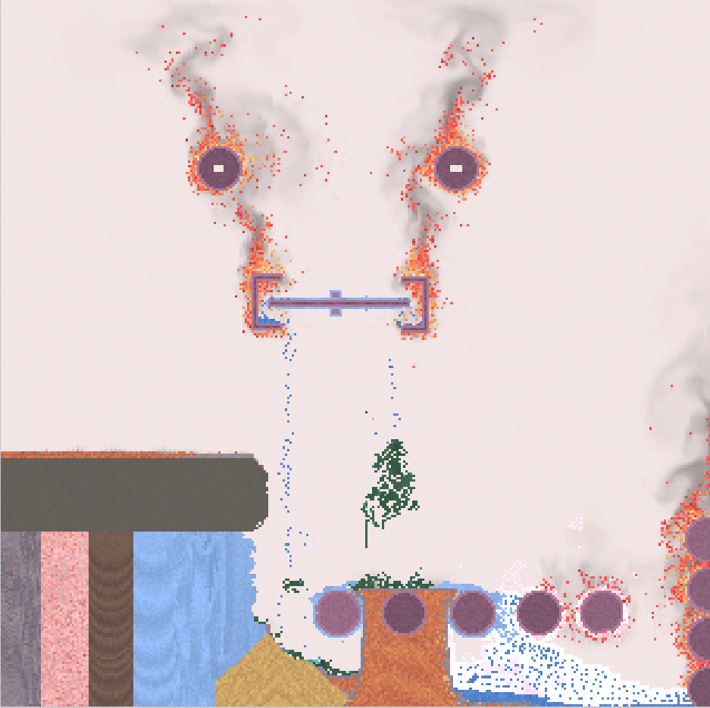

As a curious person, I just wanted to try out the different interactions of the elements provided by the webpage. I find it quite interesting and this is the outcome of my work. I merely wanted to shape out eyes and mouth using the cloner and fire as it produces and endless amount of the material applied to it. Other elements in the image aren’t really that relevant except for the fact that it depicts my curiosity.